Requirements/Design Specification

**July2015 GH573**

**Customer and Office CSAs no longer showing Fixed Fee %, only text indicating Fixed Fee (CR 14072)**

Revision History

|  |  |  |  |
| --- | --- | --- | --- |
| **Date** | **Revision** | **Description** | **Author** |
| 5/18/2015 | 1.0 | Initial Version with Requirements | Gaurav Dawar |
|  |  |  |  |
|  |  |  |  |
|  |  |  |  |
|  |  |  |  |

The information furnished herein by Republic Services Inc. is proprietary and confidential to Republic Services Inc. personnel and is not to be duplicated, published, or disclosed to any third party in whole or in part without permission from Republic Services, Inc.

© Copyright 2012, Republic Services Inc. - All rights reserved.

Table of contents

1 Business Requirements 6

1.1 Purpose of the Design Specification 6

1.1.1 Bug list for current release 6

2 Competitor Overview and Assumptions 6

3 Design 6

4 Impacted Systems (InfoPro, TIBCO and BI) 8

5 Report Changes 8

6 Appendix 8

# Business Requirements

## Purpose of the Design Specification

This document highlights items to be fixed and implemented for the titled release.

### Bug list for current release

| GitHub Item  Number | **Description** |
| --- | --- |
| 573 | Customer and Office CSAs no longer showing Fixed Fee %, only text indicating Fixed Fee (CR 14072) |

# Overview and Assumptions

Since the Header which use to dynamically change based on the inputs on the pricing page is now fixed to be static for existing customers and FRF and ERF readonly variables do not contain the % values for Fixed FRF and ERF anymore(which is a bug), we have to fix the header tohave Fixed FRF and ERF %s if an existing account has Fixed Fees applied to it, So that these values can be used as an output to print in CSA.

# Design

## #573 Customer and Office CSAs no longer showing Fixed Fee %, only text indicating Fixed Fee (CR 14072)

% value for fixed FRF and ERF to be displayed in CSA for the existing customers having an option of Fixed fees.

we have to fix the header tohave Fixed FRF and ERF %s if an existing account has Fixed Fees applied to it, So that these values can be used as an output to print in CSA. This change will be made to the values of :

eRFreadOnly_quote

fRF_readOnly_quote

in “setSiteCustomerReadOnlyAttributes” commerce library function.

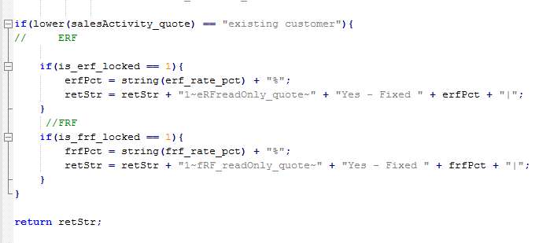

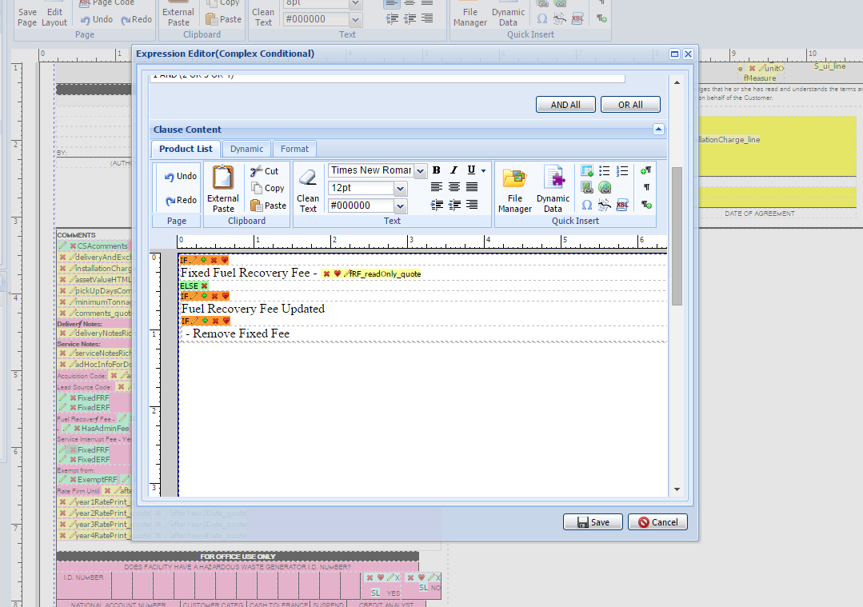

# Impacted Systems (InfoPro, TIBCO and BI)

No new variables were created hence should not affect InfoPro AAE process.

# Report Changes

NA

# Appendix